**Online Shopping management System**



Session: 2022 – 2026

**Submitted by:**

Muhammad Adnan 2022-CS-59

**Supervised by:**

Mam Maida Shahid

Mr. Irzam Liaqat

Department of Computer Science

**University of Engineering and Technology**

**Lahore Pakistan**

**documentation**

* **Short Description of your project**
  + I want to make a program to help online shopping to maintain their expanse records, and calculate their sales .it also helps the customer to buy
  + Needed things on their own. It saves the record of available stocks and sales.
  + It saves the waste of time.
* **Users of Application**
  + This application is particularly for online business(shopping) provide (like books, fast foods, and electric device).
  + My main target is E-Comerce
  + Admin: Admin will access the additional feature like prices, sales and total income
* **Functional Requirements**
  + Functional requirements are a detailed description of what a system, product, or service must do to meet the needs and expectations
  + Use the following format to write the Functional Requirements

|  |  |  |  |  |
| --- | --- | --- | --- | --- |
| User Story ID | *As a* | *I want to perform* | | *So that I can* |
| **1** | Admin | Load the data from files | | See the details of products, prices, quantity and sale |
| **2** | Admin | Add the products | | Add the new products |
| **3** | Admin | update the products | | update the prices of products |
| **4** | Admin | delete the products | | delete the unavailable products |
| **5** | Admin | See the available stocks | | view the available stocks |
| **6** | Admin | See the sale of each products. | | view the sale of each products |
| **7** | Admin | See the total sale of all products | | View the total sale of products |
| **8** | User | Search the product | | Search the available stock |
| **9** | User | See the product details | | View the products details |
| **10** | User | order the products | | order the products |
|  | | |

* **Wireframes**

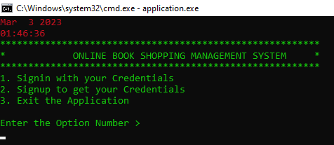

**Login page**

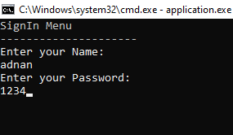

**Admin password**

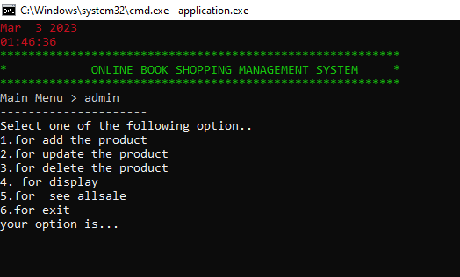

**Admin menu**

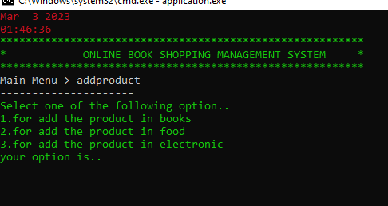

**Add product menu**

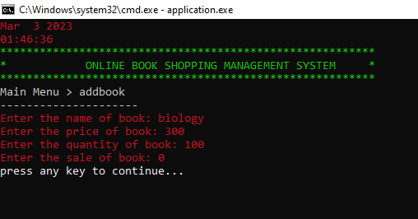

**Add products**

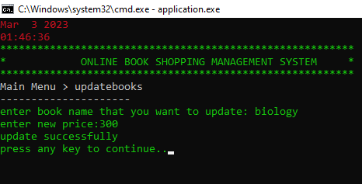

**Update prices**

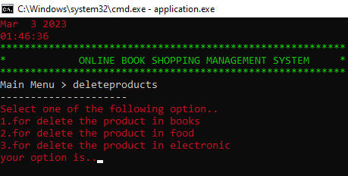

**Delete unavavilable products**

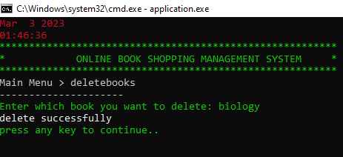

**Delete products**

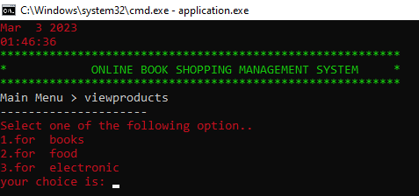

**View available stocks**

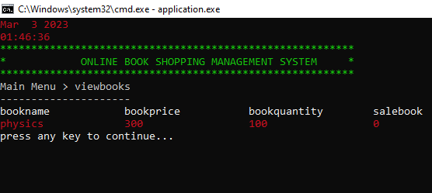

**See products**

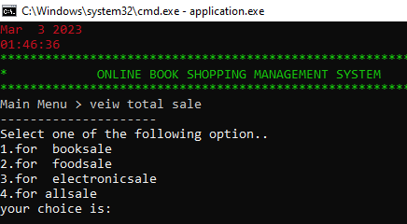

**View sale and total income**

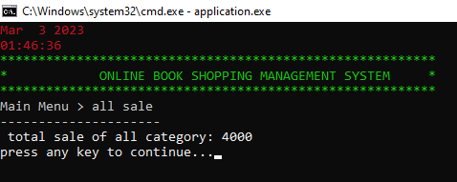

**Total income**

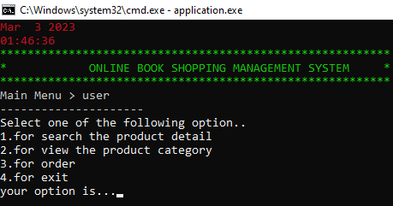

**User menu**

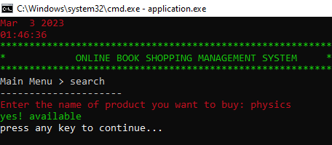

**Search products**

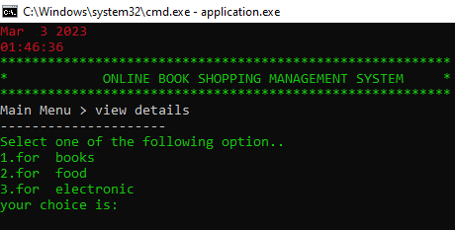

**View available stocks**

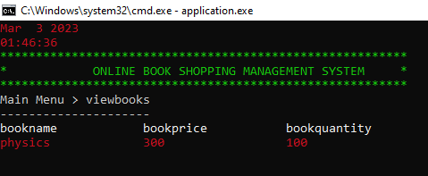

**View book available stocks**

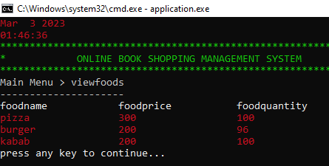

**View food available stocks**

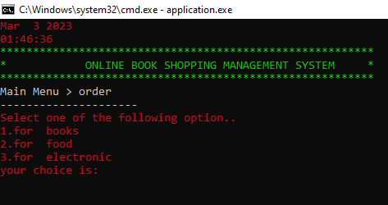

**Order the products**

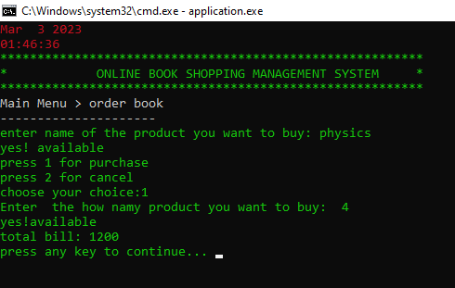

**Order the products**

**Important Instructions**

* **Data Structures (Parallel Arrays)**
* // arrays
* string bookname[50];
* string foodname[50];
* string electronicname[50];
* int bookprice[50], foodprice[50], electronicprice[50];
* int bookquantity[50];
* int foodquantity[50];
* int electronicquantity[50];
* int salebook[50];
* int salefood[50];
* int saleelectronic[50];
* **Function Prototypes**
* void header();
* const int userArrSize = 50;
* string users[userArrSize];
* string passwords[userArrSize];
* string roles[userArrSize];
* int usersCount = 0;
* void loginmenu();
* string signIn(string name, string password);
* bool signUp(string name, string password, string role);
* void loadsignup();
* string inputsignup(string name, int num);
* void subMenuBeforeMainMenu(string submenu);
* void subMenu(string submenu);
* int loginMenu();
* int loginOption = 0;
* void admin();
* // admin functions
* void updateproducts();
* void updatebook();
* void storeupdatebook();
* void updatefood();
* void storeupdatefood();
* void updateelectronic();
* void storeupdateelectronic();
* void addproducts();
* void addbook();
* void storebook(string bookname, int bookprice, int bookquantity, int salebook);
* void addelectronic();
* void storeelectronic(string electronicname, int electronicprice, int electronicquantity, int saleelectronic);
* void addfood();
* void storefood(string foodname, int foodprice, int foodquantity, int salefood);
* void deleteproducts();
* void deletebook();
* void storedeletebook();
* void deletefood();
* void storedeletefood();
* void deleteelectronic();
* void storedeleteelectronic();
* void display();
* void displaybook();
* void displayfood();
* void displayelectronic();
* //  loadfunctions
* void loadbook();
* void loadfood();
* void loadelectronic();
* string inputbook(string, int);
* string inputfood(string, int);
* string inputelectronic(string, int);
* void storesalebook();
* void storesalefood();
* void storesaleelectronic();
* void allsalebook();
* void storetotalbooksale();
* void storetotalfoodsale();
* void storetotalelectronicsale();
* void loadtotalbooksale();
* void loadtotalfoodsale();
* void loadtotalelectronicsale();
* void allsalefood();
* void allsaleelectronic();
* void allsale();
* void storeincome();
* void loadincome();
* void totalsale();
* // user funtions
* void user();
* void search();
* void viewdetails();
* void viewbook();
* void viewfood();
* void viewelectronic();
* void order();
* void orderbook();
* void orderfood();
* void orderelectronic();
* **Functions Working Flow**
  + Here you have to draw a diagram that will show how you are calling your functions. This will show how you have designed the flow of your code.
  + Here is an example of your Functions Working Flow diagram.

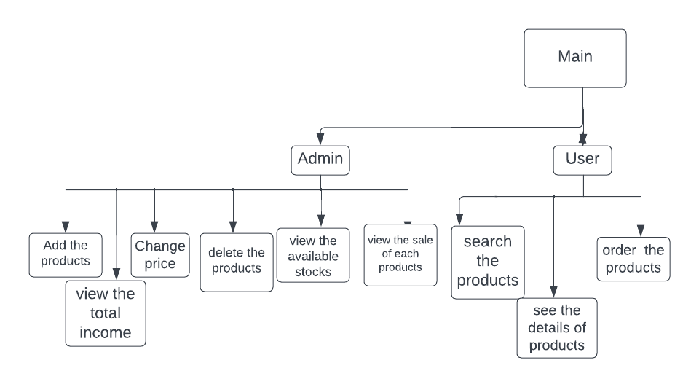

* **Complete Code of the Business Application**
* #include <iostream>
* #include <fstream>
* #include <conio.h>
* #include <iomanip>
* #include <windows.h>
* #include <time.h>
* using namespace std;
* void isnotvalid();
* HANDLE h = GetStdHandle(STD_OUTPUT_HANDLE);
* // arrays
* string bookname[50];
* string foodname[50];
* string electronicname[50];
* int bookprice[50], foodprice[50], electronicprice[50];
* int bookquantity[50];
* int foodquantity[50];
* int electronicquantity[50];
* int salebook[50];
* int salefood[50];
* int saleelectronic[50];
* // Arrays index
* int idxbook = 0;
* int idxfood = 0;
* int idxelectronic = 0;
* int booksale = 0;
* int foodsale = 0;
* int electronicsale = 0;
* int income = 0;
* // functions//
* void header();
* const int userArrSize = 50;
* string users[userArrSize];
* string passwords[userArrSize];
* string roles[userArrSize];
* int usersCount = 0;
* void loginmenu();
* string signIn(string name, string password);
* bool signUp(string name, string password, string role);
* void loadsignup();
* string inputsignup(string name, int num);
* void subMenuBeforeMainMenu(string submenu);
* void subMenu(string submenu);
* int loginMenu();
* int loginOption = 0;
* void admin();
* //  loadfunctions
* void loadbook();
* void loadfood();
* void loadelectronic();
* string inputbook(string, int);
* string inputfood(string, int);
* string inputelectronic(string, int);
* // admin functions
* void updateproducts();
* void updatebook();
* void storeupdatebook();
* void updatefood();
* void storeupdatefood();
* void updateelectronic();
* void storeupdateelectronic();
* void addproducts();
* void addbook();
* void storebook(string bookname, int bookprice, int bookquantity, int salebook);
* void addelectronic();
* void storeelectronic(string electronicname, int electronicprice, int electronicquantity, int saleelectronic);
* void addfood();
* void storefood(string foodname, int foodprice, int foodquantity, int salefood);
* void deleteproducts();
* void deletebook();
* void storedeletebook();
* void deletefood();
* void storedeletefood();
* void deleteelectronic();
* void storedeleteelectronic();
* void display();
* void displaybook();
* void displayfood();
* void displayelectronic();
* // sales functions
* void storesalebook();
* void storesalefood();
* void storesaleelectronic();
* void allsalebook();
* void storetotalbooksale();
* void storetotalfoodsale();
* void storetotalelectronicsale();
* void loadtotalbooksale();
* void loadtotalfoodsale();
* void loadtotalelectronicsale();
* void allsalefood();
* void allsaleelectronic();
* void allsale();
* void storeincome();
* void loadincome();
* void totalsale();
* // user funtions
* void user();
* void search();
* void viewdetails();
* void viewbook();
* void viewfood();
* void viewelectronic();
* void order();
* void orderbook();
* void orderfood();
* void orderelectronic();
* int number;
* main()
* {
* system("cls");
* header();
* loadbook();
* loadfood();
* loadelectronic();
* loadtotalbooksale();
* loadtotalfoodsale();
* loadtotalelectronicsale();
* loadsignup();
* while (loginOption != 3)
* {
* system("cls");
* header();
* loginOption = loginMenu();
* SetConsoleTextAttribute(h, 4);
* subMenuBeforeMainMenu("Login");
* storeincome();
* if (loginOption == 1)
* {
* system("cls");
* string name;
* string password;
* string role;
* subMenuBeforeMainMenu("SignIn");
* cout << "Enter your Name: " << endl;
* cin>> name;
* cout << "Enter your Password: " << endl;
* cin >> password;
* role = signIn(name, password);
* SetConsoleTextAttribute(h, 15);
* if (role == "admin")
* {
* admin();
* }
* else if (role == "user")
* {
* user();
* }
* else if (role == "undefined")
* {
* cout << "You Entered wrong Credentials" << endl;
* }
* }
* else if (loginOption == 2)
* {
* system("cls");
* string name;
* string password;
* string role;
* SetConsoleTextAttribute(h, 7);
* subMenuBeforeMainMenu("SignUp");
* cout << "Enter your Name: " << endl;
* cin>> name;
* cout << "Enter your Password: " << endl;
* cin >> password;
* cout << "Enter your Role (admin or user and manager): " << endl;
* cin >> role;
* SetConsoleTextAttribute(h, 15);
* bool isValid = signUp(name, password, role);
* if (isValid)
* {
* cout << "SignedUp Successfully" << endl;
* }
* if (!isValid)
* {
* cout << "Users in the System have exceeded the Capacity" << endl;
* }
* cout << "press any key to continue..";
* getch();
* }
* }
* }
* int loginMenu()
* {
* int opti;
* SetConsoleTextAttribute(h, 10);
* cout << "1. Signin with your Credentials" << endl;
* cout << "2. Signup to get your Credentials" << endl;
* cout << "3. Exit the Application" << endl;
* cout << endl;
* cout << "Enter the Option Number > ";
* while (!(cin >> opti))
* {
* isnotvalid();
* }
* SetConsoleTextAttribute(h, 15);
* return opti;
* }
* string signIn(string name, string password)
* {
* for (int index = 0; index < usersCount; index++)
* {
* if (users[index] == name && passwords[index] == password)
* {
* return roles[index];
* }
* }
* return "undefined";
* }
* void appsignin(string users, string passwords, string roles)
* {
* fstream file;
* file.open("signup.txt", ios::app);
* file << endl
* << users << ',' << passwords << ',' << roles;
* file.close();
* }
* bool signUp(string name, string password, string role)
* {
* if (usersCount < userArrSize)
* {
* users[usersCount] = name;
* passwords[usersCount] = password;
* roles[usersCount] = role;
* usersCount++;
* appsignin(users[usersCount], passwords[usersCount], roles[usersCount]);
* return true;
* }
* else
* {
* return false;
* }
* }
* void loadsignup()
* {
* string line;
* fstream file;
* file.open("signup.txt", ios::in);
* while (getline(file, line))
* {
* users[usersCount] = inputsignup(line, 1);
* passwords[usersCount] = inputsignup(line, 2);
* roles[usersCount] = inputsignup(line, 3);
* usersCount++;
* }
* }
* string inputsignup(string line, int num)
* {
* int commacount = 1;
* string item;
* for (int idx = 0; idx < line.length(); idx++)
* {
* if (line[idx] == ',')
* {
* commacount++;
* }
* else if (commacount == num)
* {
* item = item + line[idx];
* }
* }
* return item;
* }
* void subMenuBeforeMainMenu(string submenu)
* {
* SetConsoleTextAttribute(h, 7);
* string message = submenu + " Menu";
* cout << message << endl;
* cout << "---------------------" << endl;
* SetConsoleTextAttribute(h, 15);
* }
* void subMenu(string submenu)
* {
* SetConsoleTextAttribute(h, 7);
* string message = "Main Menu > " + submenu;
* cout << message << endl;
* cout << "---------------------" << endl;
* SetConsoleTextAttribute(h, 15);
* }
* void loginmenu()
* {
* SetConsoleTextAttribute(h, 7);
* cout << "1. for admin" << endl;
* cout << "2. for user" << endl;
* cout << " 3.for exit" << endl;
* SetConsoleTextAttribute(h, 15);
* }
* void admin()
* {
* system("cls");
* header();
* int option;
* while (option != 6)
* {
* system("cls");
* header();
* SetConsoleTextAttribute(h, 7);
* subMenu("admin");
* cout << "Select one of the following option.." << endl;
* cout << "1.for add the product" << endl;
* cout << "2.for update the product" << endl;
* cout << "3.for delete the product" << endl;
* cout << "4. for display " << endl;
* cout << "5.for  see allsale" << endl;
* cout << "6.for exit" << endl;
* cout << "your option is...";
* while (!(cin >> option))
* {
* isnotvalid();
* }
* SetConsoleTextAttribute(h, 15);
* if (option == 1)
* {
* addproducts();
* }
* else if (option == 2)
* {
* updateproducts();
* }
* else if (option == 3)
* {
* deleteproducts();
* }
* else if (option == 4)
* {
* display();
* }
* else if (option == 5)
* {
* totalsale();
* }
* }
* }
* void header()
* {
* SetConsoleTextAttribute(h, 4);
* cout << __DATE__ << endl;
* cout << __TIME__ << endl;
* SetConsoleTextAttribute(h, 10);
* cout << "*********************************************************" << endl;
* cout << "*            ONLINE BOOK SHOPPING MANAGEMENT SYSTEM     *" << endl;
* cout << "*********************************************************" << endl;
* SetConsoleTextAttribute(h, 15);
* }
* void loadbook()
* {
* fstream file;
* string word;
* file.open("addbookfile.txt", ios::in);
* while (getline(file, word))
* {
* bookname[idxbook] = inputbook(word, 1);
* bookprice[idxbook] = stoi(inputbook(word, 2));
* bookquantity[idxbook] = stoi(inputbook(word, 3));
* salebook[idxbook] = stoi(inputbook(word, 4));
* idxbook++;
* }
* file.close();
* }
* string inputbook(string word, int field)
* {
* int commacount = 1;
* string item;
* for (int idx = 0; idx < word.length(); idx++)
* {
* if (word[idx] == ',')
* {
* commacount++;
* }
* else if (commacount == field)
* {
* item = item + word[idx];
* }
* }
* return item;
* }
* void loadfood()
* {
* fstream file;
* string word;
* file.open("addfoodfile.txt", ios::in);
* while (getline(file, word))
* {
* foodname[idxfood] = inputfood(word, 1);
* foodprice[idxfood] = stoi(inputfood(word, 2));
* foodquantity[idxfood] = stoi(inputfood(word, 3));
* salefood[idxfood] = stoi(inputfood(word, 4));
* idxfood++;
* }
* file.close();
* }
* string inputfood(string word, int field)
* {
* int commacount = 1;
* string item;
* for (int idx = 0; idx < word.length(); idx++)
* {
* if (word[idx] == ',')
* {
* commacount++;
* }
* else if (commacount == field)
* {
* item = item + word[idx];
* }
* }
* return item;
* }
* void loadelectronic()
* {
* fstream file;
* string word;
* file.open("addelectronicfile.txt", ios::in);
* while (getline(file, word))
* {
* electronicname[idxelectronic] = inputelectronic(word, 1);
* electronicprice[idxelectronic] = stoi(inputelectronic(word, 2));
* electronicquantity[idxelectronic] = stoi(inputelectronic(word, 3));
* saleelectronic[idxelectronic] = stoi(inputelectronic(word, 4));
* idxelectronic++;
* }
* file.close();
* }
* string inputelectronic(string word, int field)
* {
* int commacount = 1;
* string item;
* for (int idx = 0; idx < word.length(); idx++)
* {
* if (word[idx] == ',')
* {
* commacount++;
* }
* else if (commacount == field)
* {
* item = item + word[idx];
* }
* }
* return item;
* }
* void addproducts()
* {
* system("cls");
* header();
* subMenu("addproduct");
* int option;
* SetConsoleTextAttribute(h, 10);
* cout << "Select one of the following option.." << endl;
* cout << "1.for add the product in books" << endl;
* cout << "2.for add the product in food" << endl;
* cout << "3.for add the product in electronic" << endl;
* cout << "your option is..";
* while (!(cin >> option))
* {
* isnotvalid();
* }
* SetConsoleTextAttribute(h, 15);
* if (option == 1)
* {
* addbook();
* }
* if (option == 2)
* {
* addfood();
* }
* if (option == 3)
* {
* addelectronic();
* }
* cout << "press any key to continue... ";
* getch();
* }
* void storebook(string bookname, int bookprice, int bookquantity, int salebook)
* {
* fstream file;
* file.open("addbookfile.txt", ios::app);
* file << endl
* << bookname << ',' << bookprice << ',' << bookquantity << ',' << salebook;
* file.close();
* }
* void addbook()
* {
* system("cls");
* header();
* subMenu("addbook");
* SetConsoleTextAttribute(h, 4);
* cout << "Enter the name of book: ";
* cin >> bookname[idxbook];
* cout << "Enter the price of book: ";
* cin >> bookprice[idxbook];
* cout << "Enter the quantity of book: ";
* cin >> bookquantity[idxbook];
* cout << "Enter the sale of book: ";
* cin >> salebook[idxbook];
* SetConsoleTextAttribute(h, 15);
* storebook(bookname[idxbook], bookprice[idxbook], bookquantity[idxbook], salebook[idxbook]);
* idxbook++;
* }
* void addfood()
* {
* system("cls");
* header();
* subMenu("addfood");
* SetConsoleTextAttribute(h, 10);
* cout << "Enter the name of food: ";
* cin >> foodname[idxfood];
* cout << "Enter the price of food: ";
* cin >> foodprice[idxfood];
* cout << "Enter the quantity of food: ";
* cin >> foodquantity[idxfood];
* cout << "Enter the sale of food: ";
* cin >> salefood[idxfood];
* SetConsoleTextAttribute(h, 15);
* storefood(foodname[idxfood], foodprice[idxfood], foodquantity[idxfood], salefood[idxfood]);
* idxfood++;
* }
* void storefood(string foodname, int foodprice, int foodquantity, int salefood)
* {
* fstream file;
* file.open("addfoodfile.txt", ios::app);
* file << endl
* << foodname << ',' << foodprice << ',' << foodquantity << ',' << salefood;
* file.close();
* }
* void addelectronic()
* {
* system("cls");
* header();
* subMenu("addelectronic");
* SetConsoleTextAttribute(h, 10);
* cout << "Enter the name of electric: ";
* cin >> electronicname[idxelectronic];
* cout << "Enter the price of electric: ";
* while (!(cin >> electronicprice[idxelectronic]))
* {
* isnotvalid();
* }
* cout << "Enter the quantity of electric: ";
* while (!(cin >> electronicquantity[idxelectronic]))
* {
* isnotvalid();
* }
* cout << "Enter the sale of electric: ";
* while (!(cin >> saleelectronic[idxelectronic]))
* {
* isnotvalid();
* }
* storeelectronic(electronicname[idxelectronic], electronicprice[idxelectronic], electronicquantity[idxelectronic], saleelectronic[idxelectronic]);
* idxelectronic++;
* }
* void storeelectronic(string electronicname, int electronicprice, int electronicquantity, int saleelectronic)
* {
* fstream file;
* file.open("addelectronicfile.txt", ios::app);
* file << endl
* << electronicname << ',' << electronicprice << ',' << electronicquantity << ',' << saleelectronic;
* file.close();
* }
* void updateproducts()
* {
* system("cls");
* header();
* subMenu("updateproducts");
* int option;
* SetConsoleTextAttribute(h, 4);
* cout << "Select one of the following option.." << endl;
* cout << "1.for update the product in books" << endl;
* cout << "2.for update the product in food" << endl;
* cout << "3.for update the product in electronic" << endl;
* cout << "your option is..";
* while (!(cin >> option))
* {
* isnotvalid();
* }
* SetConsoleTextAttribute(h, 15);
* if (option == 1)
* {
* updatebook();
* }
* if (option == 2)
* {
* updatefood();
* }
* if (option == 3)
* {
* updateelectronic();
* }
* SetConsoleTextAttribute(h, 10);
* cout << "press any key to continue..";
* SetConsoleTextAttribute(h, 15);
* getch();
* }
* void updatebook()
* {
* system("cls");
* header();
* subMenu("updatebooks");
* bool exist = false;
* SetConsoleTextAttribute(h, 10);
* string bookupdate;
* cout << "enter book name that you want to update: ";
* cin >> bookupdate;
* SetConsoleTextAttribute(h, 15);
* for (int i = 0; i < idxbook; i++)
* {
* if (bookupdate == bookname[i])
* {
* SetConsoleTextAttribute(h, 10);
* cout << "enter new price:";
* cin >> bookprice[i];
* exist = true;
* break;
* }
* }
* storeupdatebook();
* if (exist == true)
* {
* cout << "update successfully" << endl;
* }
* else
* {
* cout << "update unsuccessfully" << endl;
* cout << "this book has  not exists already" << endl;
* }
* }
* void storeupdatebook()
* {
* fstream file;
* file.open("addbookfile.txt", ios::out);
* for (int idx = 0; idx < idxbook; idx++)
* {
* file << bookname[idx] << ',' << bookprice[idx] << ',' << bookquantity[idx] << ',' << salebook[idx] << endl;
* }
* file.close();
* }
* void updatefood()
* {
* system("cls");
* header();
* subMenu("updatefood");
* string which;
* bool exist;
* SetConsoleTextAttribute(h, 10);
* string foodupdate;
* cout << "enter food name that you want to update: ";
* cin >> foodupdate;
* SetConsoleTextAttribute(h, 15);
* for (int i = 0; i < idxfood; i++)
* {
* if (foodupdate == foodname[i])
* {
* SetConsoleTextAttribute(h, 10);
* cout << "enter new price:";
* cin >> foodprice[i];
* exist = true;
* break;
* }
* }
* storeupdatefood();
* if (exist == true)
* {
* cout << "update successfully" << endl;
* }
* else
* {
* cout << "update unsuccessfully" << endl;
* cout << "this food has  not exists already" << endl;
* }
* }
* void storeupdatefood()
* {
* fstream file;
* file.open("addfoodfile.txt", ios::out);
* for (int idx = 0; idx < idxfood; idx++)
* {
* file << foodname[idx] << ',' << foodprice[idx] << ',' << foodquantity[idx] << ',' << salefood[idx] << endl;
* }
* file.close();
* }
* void updateelectronic()
* {
* system("cls");
* header();
* subMenu("electronicbooks");
* bool exist;
* SetConsoleTextAttribute(h, 10);
* string electronicupdate;
* cout << "enter device name: ";
* cin >> electronicupdate;
* SetConsoleTextAttribute(h, 15);
* for (int i = 0; i < idxelectronic; i++)
* {
* if (electronicupdate == electronicname[i])
* {
* SetConsoleTextAttribute(h, 10);
* cout << "enter new price:";
* cin >> electronicprice[i];
* exist = true;
* break;
* }
* }
* storeupdateelectronic();
* if (exist == true)
* {
* cout << "update successfully" << endl;
* }
* else
* {
* cout << "update unsuccessfully" << endl;
* cout << "this device has  not exists already" << endl;
* }
* }
* void storeupdateelectronic()
* {
* fstream file;
* file.open("addelectronicfile.txt", ios::out);
* for (int idx = 0; idx < idxelectronic; idx++)
* {
* file << electronicname[idx] << ',' << electronicprice[idx] << ',' << electronicquantity[idx] << ',' << saleelectronic[idx] << endl;
* }
* file.close();
* }
* void deleteproducts()
* {
* system("cls");
* header();
* subMenu("deleteproducts");
* int option;
* SetConsoleTextAttribute(h, 4);
* cout << "Select one of the following option.." << endl;
* cout << "1.for delete the product in books" << endl;
* cout << "2.for delete the product in food" << endl;
* cout << "3.for delete the product in electronic" << endl;
* cout << "your option is..";
* while (!(cin >> option))
* {
* isnotvalid();
* }
* SetConsoleTextAttribute(h, 15);
* if (option == 1)
* {
* deletebook();
* }
* if (option == 2)
* {
* deletefood();
* }
* if (option == 3)
* {
* deleteelectronic();
* }
* SetConsoleTextAttribute(h, 10);
* cout << "press any key to continue..";
* SetConsoleTextAttribute(h, 15);
* getch();
* }
* void deletebook()
* {
* system("cls");
* header();
* subMenu("deletebooks");
* string which;
* bool exist;
* SetConsoleTextAttribute(h, 10);
* cout << "Enter which book you want to delete: ";
* cin >> which;
* int find;
* SetConsoleTextAttribute(h, 15);
* for (int i = 0; i < idxbook; i++)
* {
* if (which == bookname[i])
* {
* find = i;
* exist = true;
* break;
* }
* }
* if (exist == true)
* {
* for (int i = find; i < idxbook; i++)
* {
* bookname[i] = bookname[i + 1];
* bookprice[i] = bookprice[i + 1];
* bookquantity[i] = bookquantity[i + 1];
* salebook[i] = salebook[i + 1];
* }
* idxbook--;
* storedeletebook();
* cout << "delete successfully" << endl;
* }
* else
* {
* cout << "delete unsuccessfully" << endl;
* cout << "this book has  not exists already" << endl;
* }
* }
* void storedeletebook()
* {
* fstream file;
* file.open("addbookfile.txt", ios::out);
* for (int idx = 0; idx < idxbook; idx++)
* {
* file << bookname[idx] << ',' << bookprice[idx] << ',' << bookquantity[idx] << ',' << salebook[idx] << endl;
* }
* file.close();
* }
* void deletefood()
* {
* system("cls");
* header();
* subMenu("deletefoods");
* string which;
* bool exist;
* SetConsoleTextAttribute(h, 10);
* cout << "Enter which food you want to delete: ";
* cin >> which;
* SetConsoleTextAttribute(h, 15);
* int find;
* for (int i = 0; i < idxfood; i++)
* {
* if (which == foodname[i])
* {
* find = i;
* exist = true;
* break;
* }
* }
* if (exist == true)
* {
* for (int i = find; i < idxfood - 1; i++)
* {
* foodname[i] = foodname[i + 1];
* foodprice[i] = foodprice[i + 1];
* foodquantity[i] = foodquantity[i + 1];
* salefood[i] = salefood[i + 1];
* }
* idxfood--;
* storedeletefood();
* cout << "delete successfully" << endl;
* }
* else
* {
* cout << "delete unsuccessfully" << endl;
* cout << "this food has  not exists already" << endl;
* }
* }
* void storedeletefood()
* {
* fstream file;
* file.open("addfoodfile.txt", ios::out);
* for (int idx = 0; idx < idxfood; idx++)
* {
* file << foodname[idx] << ',' << foodprice[idx] << ',' << foodquantity[idx] << ',' << salefood[idx] << endl;
* }
* file.close();
* }
* void deleteelectronic()
* {
* system("cls");
* header();
* subMenu("deleteelectronic");
* string which;
* bool exist;
* SetConsoleTextAttribute(h, 10);
* cout << "Enter which device you want to delete: ";
* cin >> which;
* int find;
* SetConsoleTextAttribute(h, 15);
* for (int i = 0; i < idxelectronic; i++)
* {
* if (which == electronicname[i])
* {
* find = i;
* exist = true;
* break;
* }
* }
* if (exist == true)
* {
* for (int i = find; i < idxelectronic; i++)
* {
* electronicname[i] = electronicname[i + 1];
* electronicprice[i] = electronicprice[i + 1];
* electronicquantity[i] = electronicquantity[i + 1];
* saleelectronic[i] = saleelectronic[i + 1];
* }
* idxelectronic--;
* storedeleteelectronic();
* cout << "delete successfully" << endl;
* }
* else
* {
* cout << "delete unsuccessfully" << endl;
* cout << "this device has  not exists already" << endl;
* }
* }
* void storedeleteelectronic()
* {
* fstream file;
* file.open("addelectronicfile.txt", ios::out);
* for (int idx = 0; idx < idxelectronic; idx++)
* {
* file << electronicname[idx] << ',' << electronicprice[idx] << ',' << electronicquantity[idx] << ',' << saleelectronic[idx] << endl;
* }
* file.close();
* }
* void display()
* {
* system("cls");
* header();
* subMenu("viewproducts");
* int option;
* SetConsoleTextAttribute(h, 4);
* cout << "Select one of the following option.." << endl;
* cout << "1.for  books" << endl;
* cout << "2.for  food" << endl;
* cout << "3.for  electronic" << endl;
* cout << "your choice is: ";
* while (!(cin >> option))
* {
* isnotvalid();
* }
* SetConsoleTextAttribute(h, 15);
* if (option == 1)
* {
* displaybook();
* }
* if (option == 2)
* {
* displayfood();
* }
* if (option == 3)
* {
* displayelectronic();
* }
* cout << "press any key to continue... ";
* getch();
* }
* void displaybook()
* {
* system("cls");
* header();
* SetConsoleTextAttribute(h, 10);
* subMenu("viewbooks");
* cout << left << setw(20) << "bookname"
* << left << setw(20)
* << "bookprice"
* << left << setw(20)
* << "bookquantity"
* << left << setw(20)
* << "salebook" << endl;
* for (int i = 0; i < idxbook; i++)
* {
* SetConsoleTextAttribute(h, 4);
* cout << left << setw(20) << bookname[i] << left << setw(20)
* << bookprice[i] << left << setw(20)
* << bookquantity[i] << left << setw(20)
* << salebook[i] << endl;
* }
* SetConsoleTextAttribute(h, 15);
* }
* void displayfood()
* {
* system("cls");
* header();
* SetConsoleTextAttribute(h, 10);
* subMenu("viewfoods");
* cout << left << setw(20) << "foodname"
* << left << setw(20)
* << "foodprice"
* << left << setw(20)
* << "foodquantity" << left << setw(20) << "salefood" << endl;
* SetConsoleTextAttribute(h, 15);
* for (int i = 0; i < idxfood; i++)
* {
* SetConsoleTextAttribute(h, 4);
* cout << left << setw(20) << foodname[i] << left << setw(20)
* << foodprice[i] << left << setw(20)
* << foodquantity[i] << left << setw(20) << salefood[i] << endl;
* }
* SetConsoleTextAttribute(h, 15);
* }
* void displayelectronic()
* {
* system("cls");
* header();
* subMenu("viewelectricdevice");
* SetConsoleTextAttribute(h, 4);
* cout << left << setw(20) << "electronicname"
* << left << setw(20)
* << "electronicprice"
* << left << setw(20)
* << "electronicquantity"
* << left << setw(20)
* << "saledevice" << endl;
* SetConsoleTextAttribute(h, 15);
* for (int i = 0; i < idxelectronic; i++)
* {
* SetConsoleTextAttribute(h, 10);
* cout << left << setw(20) << electronicname[i] << left << setw(20)
* << electronicprice[i]
* << left << setw(20) << electronicquantity[i] << left << setw(20) << saleelectronic[i] << endl;
* }
* SetConsoleTextAttribute(h, 15);
* }
* void user()
* {
* system("cls");
* bool run = true;
* while (run)
* {
* system("cls");
* header();
* subMenu("user");
* int option;
* cout << "Select one of the following option.." << endl;
* cout << "1.for search the product detail" << endl;
* cout << "2.for view the product category" << endl;
* cout << "3.for order " << endl;
* cout << "4.for exit" << endl;
* cout << "your option is...";
* while (!(cin >> option))
* {
* isnotvalid();
* }
* if (option == 1)
* {
* search();
* }
* if (option == 2)
* {
* viewdetails();
* }
* if (option == 3)
* {
* order();
* }
* if (option == 4)
* {
* run = false;
* }
* }
* }
* void search()
* {
* system("cls");
* header();
* subMenu("search");
* string option;
* SetConsoleTextAttribute(h, 4);
* cout << "Enter the name of product you want to buy: ";
* cin >> option;
* SetConsoleTextAttribute(h, 15);
* bool count = false;
* for (int idx = 0; idx < idxbook; idx++)
* {
* if (option == bookname[idx])
* {
* count = true;
* break;
* }
* }
* for (int idx = 0; idx < idxfood; idx++)
* {
* if (option == foodname[idx])
* {
* count = true;
* break;
* }
* }
* for (int idx = 0; idx < idxelectronic; idx++)
* {
* if (option == electronicname[idx])
* {
* count = true;
* break;
* }
* }
* if (count == true)
* {
* SetConsoleTextAttribute(h, 10);
* cout << "yes! available" << endl;
* }
* else
* {
* cout << "not available" << endl;
* }
* SetConsoleTextAttribute(h, 15);
* cout << "press any key to continue...";
* getch();
* }
* void viewdetails()
* {
* system("cls");
* header();
* subMenu("view details");
* int option;
* SetConsoleTextAttribute(h, 10);
* cout << "Select one of the following option.." << endl;
* cout << "1.for  books" << endl;
* cout << "2.for  food" << endl;
* cout << "3.for  electronic" << endl;
* cout << "your choice is: ";
* while (!(cin >> option))
* {
* isnotvalid();
* }
* SetConsoleTextAttribute(h, 15);
* if (option == 1)
* {
* viewbook();
* }
* else if (option == 2)
* {
* viewfood();
* }
* else if (option == 3)
* {
* viewelectronic();
* }
* cout << "press any key to continue... ";
* getch();
* }
* void viewbook()
* {
* system("cls");
* header();
* SetConsoleTextAttribute(h, 10);
* subMenu("viewbooks");
* cout << left << setw(20) << "bookname"
* << left << setw(20)
* << "bookprice"
* << left << setw(20)
* << "bookquantity" << endl;
* for (int i = 0; i < idxbook; i++)
* {
* SetConsoleTextAttribute(h, 4);
* cout << left << setw(20) << bookname[i] << left << setw(20)
* << bookprice[i] << left << setw(20)
* << bookquantity[i] << endl;
* }
* getch();
* SetConsoleTextAttribute(h, 15);
* }
* void viewfood()
* {
* system("cls");
* header();
* SetConsoleTextAttribute(h, 10);
* subMenu("viewfoods");
* cout << left << setw(20) << "foodname"
* << left << setw(20)
* << "foodprice"
* << left << setw(20)
* << "foodquantity" << endl;
* SetConsoleTextAttribute(h, 15);
* for (int i = 0; i < idxfood; i++)
* {
* SetConsoleTextAttribute(h, 4);
* cout << left << setw(20) << foodname[i]
* << left << setw(20) << foodprice[i]
* << left << setw(20) << foodquantity[i] << endl;
* }
* SetConsoleTextAttribute(h, 15);
* }
* void viewelectronic()
* {
* system("cls");
* header();
* subMenu("viewelectricdevice");
* SetConsoleTextAttribute(h, 4);
* cout << left << setw(20) << "electronicname"
* << left << setw(20)
* << "electronicprice"
* << left << setw(20)
* << "electronicquantity" << endl;
* SetConsoleTextAttribute(h, 15);
* for (int i = 0; i < idxelectronic; i++)
* {
* SetConsoleTextAttribute(h, 10);
* cout << left << setw(20) << electronicname[i]
* << left << setw(20) << electronicprice[i]
* << left << setw(20) << electronicquantity[i] << endl;
* }
* SetConsoleTextAttribute(h, 15);
* }
* void order()
* {
* system("cls");
* header();
* subMenu("order");
* int option;
* SetConsoleTextAttribute(h, 4);
* cout << "Select one of the following option.." << endl;
* cout << "1.for  books" << endl;
* cout << "2.for  food" << endl;
* cout << "3.for  electronic" << endl;
* cout << "your choice is: ";
* while (!(cin >> option))
* {
* isnotvalid();
* }
* SetConsoleTextAttribute(h, 15);
* if (option == 1)
* {
* orderbook();
* }
* else if (option == 2)
* {
* orderfood();
* }
* else if (option == 3)
* {
* orderelectronic();
* }
* cout << "press any key to continue... ";
* getch();
* }
* void orderbook()
* {
* system("cls");
* header();
* subMenu("order book");
* string option;
* int confirm;
* SetConsoleTextAttribute(h, 10);
* cout << "enter name of the product you want to buy: ";
* cin >> option;
* int b;
* bool count = false;
* for (int idx = 0; idx < idxbook; idx++)
* {
* if (option == bookname[idx])
* {
* count = true;
* b = idx;
* break;
* }
* }
* if (count == true)
* {
* cout << "yes! available" << endl;
* SetConsoleTextAttribute(h, 10);
* cout << "press 1 for purchase " << endl;
* cout << "press 2 for cancel " << endl;
* cout << "choose your choice:";
* cin >> confirm;
* if (confirm == 1)
* {
* int quant;
* cout << "Enter  the how namy product you want to buy:  ";
* cin >> quant;
* if (quant < bookquantity[b])
* {
* cout << "yes!available" << endl;
* salebook[b] = salebook[b] + quant;
* bookquantity[b] = bookquantity[b] - quant;
* booksale = booksale + (quant * bookprice[b]);
* cout << "total bill: " << quant * bookprice[b] << endl;
* storetotalbooksale();
* storesalebook();
* }
* else
* {
* cout << "not available";
* }
* }
* }
* else
* {
* cout << "not available" << endl;
* }
* }
* void storesalebook()
* {
* fstream file;
* file.open("addbookfile.txt", ios::out);
* for (int idx = 0; idx < idxbook; idx++)
* {
* file << bookname[idx] << ',' << bookprice[idx] << ',' << bookquantity[idx] << ',' << salebook[idx] << endl;
* }
* file.close();
* }
* void orderfood()
* {
* system("cls");
* header();
* subMenu("order food");
* string option;
* int confirm;
* cout << "enter name of the product you want to buy: ";
* cin >> option;
* int b;
* bool count = false;
* for (int idx = 0; idx < idxfood; idx++)
* {
* if (option == foodname[idx])
* {
* count = true;
* b = idx;
* break;
* }
* }
* if (count = true)
* {
* cout << "yes! available" << endl;
* cout << "press 1 for purchase " << endl;
* cout << "press 2 for cancel " << endl;
* cout << "choose your choice:";
* while (!(cin >> confirm))
* {
* isnotvalid();
* }
* if (confirm == 1)
* {
* int quant;
* cout << "Enter  the how namy product you want to buy:  ";
* while (!(cin >> quant))
* {
* isnotvalid();
* }
* if (quant < foodquantity[b])
* {
* cout << "yes! AVAILABLE" << endl;
* salefood[b] = salefood[b] + quant;
* foodquantity[b] = foodquantity[b] - quant;
* foodsale = foodsale + (quant * foodprice[b]);
* cout << "total bill: " << quant * foodprice[b] << endl;
* storesalefood();
* storetotalfoodsale();
* }
* else
* {
* cout << "not available";
* }
* }
* }
* else
* {
* cout << "not available" << endl;
* }
* }
* void storesalefood()
* {
* fstream file;
* file.open("addfoodfile.txt", ios::out);
* for (int idx = 0; idx < idxfood; idx++)
* {
* file << foodname[idx] << ',' << foodprice[idx] << ',' << foodquantity[idx] << ',' << salefood[idx] << endl;
* }
* file.close();
* }
* void orderelectronic()
* {
* system("cls");
* header();
* subMenu("order electricdevice");
* string option;
* int confirm;
* cout << "enter name of the product you want to buy: ";
* cin >> option;
* int b;
* bool count = false;
* for (int idx = 0; idx < idxelectronic; idx++)
* {
* if (option == electronicname[idx])
* {
* count = true;
* b = idx;
* break;
* }
* }
* if (count = true)
* {
* cout << "yes! available" << endl;
* cout << "press 1 for purchase " << endl;
* cout << "press 2 for cancel " << endl;
* cout << "choose your choice:";
* while (!(cin >> confirm))
* {
* isnotvalid();
* }
* if (confirm == 1)
* {
* int quant;
* cout << "Enter  the how namy product you want to buy:  ";
* while (!(cin >> quant))
* {
* isnotvalid();
* }
* if (quant < electronicquantity[b])
* {
* cout << "yes! available" << endl;
* saleelectronic[b] = saleelectronic[b] + quant;
* electronicquantity[b] = electronicquantity[b] - quant;
* electronicsale = electronicsale + (quant * electronicprice[b]);
* cout << "total bill: " << quant * electronicprice[b] << endl;
* storesaleelectronic();
* storetotalelectronicsale();
* }
* }
* }
* else
* {
* cout << "not available" << endl;
* }
* }
* void storesaleelectronic()
* {
* fstream file;
* file.open("addelectronicfile.txt", ios::out);
* for (int idx = 0; idx < idxelectronic; idx++)
* {
* file << electronicname[idx] << ',' << electronicprice[idx] << ',' << electronicquantity[idx] << ',' << saleelectronic[idx] << endl;
* }
* file.close();
* }
* void allsalebook()
* {
* system("cls");
* header();
* subMenu("veiw booksale");
* cout << left << setw(20) << "booksale"
* << left << setw(20)
* << "bookquantity" << endl;
* for (int i = 0; i < idxbook; i++)
* {
* cout << left << setw(20) << salebook[i]
* << left << setw(20) << bookquantity[i] << endl;
* }
* cout << "________________________________________________" << endl;
* cout << "total book sale: " << booksale << endl;
* cout << "________________________________________________" << endl;
* getch();
* }
* void storetotalbooksale()
* {
* fstream file;
* file.open("salebook.txt", ios::out);
* file << booksale;
* file.close();
* }
* void loadtotalbooksale()
* {
* fstream file;
* file.open("salebook.txt", ios::in);
* file >> booksale;
* file.close();
* }
* void allsalefood()
* {
* system("cls");
* header();
* subMenu("view foodsale");
* cout << left << setw(20) << "foodsale"
* << left << setw(20)
* << "foodquantity" << endl;
* for (int i = 0; i < idxfood; i++)
* {
* cout << left << setw(20) << salefood[i]
* << left << setw(20) << foodquantity[i] << endl;
* }
* cout << "________________________________________________" << endl;
* cout << "total food sale: " << foodsale << endl;
* cout << "________________________________________________" << endl;
* getch();
* }
* void storetotalfoodsale()
* {
* fstream file;
* file.open("salefood.txt", ios::out);
* file << foodsale;
* file.close();
* }
* void loadtotalfoodsale()
* {
* fstream file;
* file.open("salefood.txt", ios::in);
* file >> foodsale;
* file.close();
* }
* void allsaleelectronic()
* {
* system("cls");
* header();
* subMenu("veiw device sale");
* cout << left << setw(20) << "electronicsale"
* << left << setw(20)
* << "electronicquantity" << endl;
* for (int i = 0; i < idxelectronic; i++)
* {
* cout << left << setw(20) << saleelectronic[i]
* << left << setw(20) << electronicquantity[i] << endl;
* }
* cout << "________________________________________________" << endl;
* cout << "total electronic sale: " << electronicsale << endl;
* cout << "________________________________________________" << endl;
* getch();
* }
* void storetotalelectronicsale()
* {
* fstream file;
* file.open("saleelectronic.txt", ios::out);
* file << electronicsale;
* file.close();
* }
* void loadtotalelectronicsale()
* {
* fstream file;
* file.open("saleelectronic.txt", ios::in);
* file >> electronicsale;
* file.close();
* }
* void totalsale()
* {
* system("cls");
* header();
* subMenu("veiw total sale");
* int option;
* cout << "Select one of the following option.." << endl;
* cout << "1.for  booksale" << endl;
* cout << "2.for  foodsale" << endl;
* cout << "3.for  electronicsale" << endl;
* cout << "4.for allsale" << endl;
* cout << "your choice is: ";
* while (!(cin >> option))
* {
* isnotvalid();
* }
* if (option == 1)
* {
* allsalebook();
* }
* else if (option == 2)
* {
* allsalefood();
* }
* else if (option == 3)
* {
* allsaleelectronic();
* }
* else if (option == 4)
* {
* allsale();
* }
* cout << "press any key to continue...";
* getch();
* }
* void allsale()
* {
* system("cls");
* header();
* subMenu("all sale");
* income = booksale + foodsale + electronicsale;
* cout << " total sale of all category: " << income << endl;
* storeincome();
* loadincome();
* }
* void loadincome()
* {
* fstream file;
* file.open("income.txt", ios::in);
* file >> income;
* file.close();
* }
* void storeincome()
* {
* fstream file;
* file.open("income.txt", ios::out);
* file << income;
* file.close();
* }
* void isnotvalid()
* {
* cout << "error: entera number";
* cin.clear();
* cin.ignore(123, '\n');
* }
* **Weakness in the Business Application**

Do not calculate the profits

* **Future Directions**

I wil calculate the profit and proper bill syste

**Student Reg. No. :**   **Student Name.**

|  |  |  |  |  |
| --- | --- | --- | --- | --- |
|  | **A-Extensive Evidence** | **B-Convincing Evidence** | **C-Limited Evidence** | **D-No Evidence** |
| Documentation Formatting  **Grade:** | All the documentation meets all the criteria. | Documentation is well formatted but some of the criteria is not fulfilled. | Documentation is required a lot of improvement. | Documentation is not Available |
| **Documentation Formatting Criteria:** In **Binder**, **Title** Page, **Header**-Footers, Font **Style**, Font **Size** all are all consistence and according to given **guidelines**. Project **Poster** is professionally design and well presented | | | | |
| Documentation Contents  **Grade:** | Documentation includes all of the criteria. | Documentation meet more than 80% of the criteria given. | Documentation meet more than 50% of the criteria. | When the documentation meet less than 50% of the criteria. |
| **Documentation Contents Criteria:** **Title** Page - **Table** of Contents - Project **Abstract** - **Functional** Requirements - **Wire** Frames –**Data Flow** Diagram-**Data** Structure (Arrays)-**Function** Headers and Description -Project **Code.** - **Weakness** in the Project and **Future** Directions. - **Conclusion** and What your **Learn** from the Project and Course and What is your **Future** Planning. | | | | |
| Project Complexity  **Grade:** | Project has at least 2 user’s types and each user has at least 5 functionalities. | Project complexity meet 80% criteria given in extensive evidence | Project complexity meet 50% criteria given in extensive evidence | Project complexity meet less than 50% criteria given in extensive evidence |
| Code Style  **Grade:** | All Code style criteria is followed | All code style criteria followed but some improvements required | lot of improvements required in coding style. | **Did not follow** code style, |
| **Code Style Criteria:**  Consistent code style. Code is well indented. Variable and Function names are well defined.  White Spaces are well used. Comments are added. | | | | |
| Code Documentation Mapping  **Grade:** | Code and documentation is synchronized. | Code and documentation does not synchronized at **some** places | Code and documentation does not synchronized at **many** places | Code and documentation **does not** synchronized. |
| Data Structure (Arrays)  **Grade:** | Data structure is sufficient for the project requirements | Data Structure is sufficient but require improvement to meet project requirements. | Data structure is not sufficient and need a lot of improvement | Data Structure is not properly identified and declared. |
| Modularity  **Grade:** | Meet all Modularity criteria | Meet all Modularity criteria but at some places it is missing | Do not sufficiently meet the modularity criteria. | No modularity or very minimum modularity. |
| **Modularity criteria:** Functions are defined for each major feature. Functions are independent (identify from parameter list and return types). | | | | |
| Validations  **Grade:** | Validations on all number type inputs are applied | Validations are applied but at some places it is missing. | Validations are missing at lot of places | No Validations are used |
| File Handling  **Grade:** | Separate files for separate data. Data in csv format | File handing require some improvements | File handing require a lot of improvements | Not implemented |
| Aesthetics of the User Interface  **Grade:** | UI is presentable. Proper coloring, Headers and clear screen is done | UI require some improvements | UI require a lot of improvements | Not implemented |
| Presentation and Demo  **Grade:** | Presentation and Demo was 100% working | Presentation and Demo require some improvements | Presentation and Demo require a lot of improvements | Presentation was not ok and Demo was not working |
| Student Understanding with the Code.  **Grade:** | Student has complete understanding how the code is working and knows the concept. | Student has good understand but some place he does not know the concepts | Student has a very little understand and lack the major concepts. | Student does not have any level of understanding of the code. |

|  |  |
| --- | --- |
| **Checked by:** |  |
| **Comments:** |  |

**Student Reg. No. :**   **Student Name.**

|  |  |  |  |  |
| --- | --- | --- | --- | --- |
|  | **A-Extensive Evidence** | **B-Convincing Evidence** | **C-Limited Evidence** | **D-No Evidence** |
| Documentation Formatting  **Grade:** | All the documentation meets all the criteria. | Documentation is well formatted but some of the criteria is not fulfilled. | Documentation is required a lot of improvement. | Documentation is not Available |
| **Documentation Formatting Criteria:** In **Binder**, **Title** Page, **Header**-Footers, Font **Style**, Font **Size** all are all consistence and according to given **guidelines**. Project **Poster** is professionally design and well presented | | | | |
| Documentation Contents  **Grade:** | Documentation includes all of the criteria. | Documentation meet more than 80% of the criteria given. | Documentation meet more than 50% of the criteria. | When the documentation meet less than 50% of the criteria. |
| **Documentation Contents Criteria:** **Title** Page - **Table** of Contents - Project **Abstract** - **Functional** Requirements - **Wire** Frames –**Data Flow** Diagram-**Data** Structure (Arrays)-**Function** Headers and Description -Project **Code.** - **Weakness** in the Project and **Future** Directions. - **Conclusion** and What your **Learn** from the Project and Course and What is your **Future** Planning. | | | | |
| Project Complexity  **Grade:** | Project has at least 2 user’s types and each user has at least 5 functionalities. | Project complexity meet 80% criteria given in extensive evidence | Project complexity meet 50% criteria given in extensive evidence | Project complexity meet less than 50% criteria given in extensive evidence |
| Code Style  **Grade:** | All Code style criteria is followed | All code style criteria followed but some improvements required | lot of improvements required in coding style. | **Did not follow** code style, |
| **Code Style Criteria:**  Consistent code style. Code is well indented. Variable and Function names are well defined.  White Spaces are well used. Comments are added. | | | | |
| Code Documentation Mapping  **Grade:** | Code and documentation is synchronized. | Code and documentation does not synchronized at **some** places | Code and documentation does not synchronized at **many** places | Code and documentation **does not** synchronized. |

|  |  |  |  |  |
| --- | --- | --- | --- | --- |
| Data Structure (Arrays)  **Grade:** | Data structure is sufficient for the project requirements | Data Structure is sufficient but require improvement to meet project requirements. | Data structure is not sufficient and need a lot of improvement | Data Structure is not properly identified and declared. |
| Modularity  **Grade:** | Meet all Modularity criteria | Meet all Modularity criteria but at some places it is missing | Do not sufficiently meet the modularity criteria. | No modularity or very minimum modularity. |
| **Modularity criteria:** Functions are defined for each major feature. Functions are independent (identify from parameter list and return types). | | | | |
| Validations  **Grade:** | Validations on all number type inputs are applied | Validations are applied but at some places it is missing. | Validations are missing at lot of places | No Validations are used |
| File Handling  **Grade:** | Separate files for separate data. Data in csv format | File handing require some improvements | File handing require a lot of improvements | Not implemented |
| Aesthetics of the User Interface  **Grade:** | UI is presentable. Proper coloring, Headers and clear screen is done | UI require some improvements | UI require a lot of improvements | Not implemented |
| Presentation and Demo  **Grade:** | Presentation and Demo was 100% working | Presentation and Demo require some improvements | Presentation and Demo require a lot of improvements | Presentation was not ok and Demo was not working |
| Student Understanding with the Code.  **Grade:** | Student has complete understanding how the code is working and knows the concept. | Student has good understand but some place he does not know the concepts | Student has a very little understand and lack the major concepts. | Student does not have any level of understanding of the code. |

|  |  |
| --- | --- |
| **Checked by:** |  |
| **Comments:** |  |